PROJECT REPORT
Summer Training — Power BI

Project Title | OPD Patient & Admissions Analysis Dashboard
Student Name | Arnav Kaushal
Roll Number | 2420675
Course & Batch | B.Tech — AI&DS
Department | Artificial Intelligence & Data Science
Institute | Chandigarh Group of Colleges, Jhanjeri
Training Period | [Add training start date] to 04 July 2026
Submission Date | 04 July 2026
Guided By | Mrs. Ashima and Mrs. Mandeep

1. Declaration

I hereby declare that the project report entitled "OPD Patient & Admissions Analysis Dashboard" submitted in partial fulfilment of the Summer Training Programme is an original piece of work carried out by me. The data used in this report has been collected from a publicly available Kaggle dataset. The dashboards and visuals shown in this report have been independently created by me in Microsoft Power BI Desktop.

I further confirm that this report or any part of it has not been submitted previously for any academic award.

Signature: ___________________________
Name: Arnav Kaushal
Date: 04 / 07 / 2026

2. Abstract

This project presents an interactive OPD Patient & Admissions Analysis dashboard built in Microsoft Power BI to help hospital administrators track patient inflow, length of stay, and readmission patterns without relying on manually compiled weekly reports. The dataset, sourced from Kaggle, contains 55,500 hospital admission records across 15 fields, including patient demographics, medical condition, admission and discharge dates, billing amount, and admission type. Power Query was used to remove 534 duplicate records and convert date fields to proper date types, and calculated columns (LOS_Days, Admission Month, Days to Next Admission) were built to support time-based analysis. Since the raw data has no patient ID, a custom DAX measure was engineered to approximate 30-day readmissions using name-based matching with CALCULATE, FILTER, and context transition logic. The final two-page dashboard combines KPI cards, bar, line, and column charts, a patient-level table, and a blood-group pie chart with interactive slicers and page navigation. Key outcomes include an average length of stay of 15.51 days, a low 1.17% readmission rate indicating strong discharge quality, and total billing of Rs. 5.43M — insights that give OPD management a real-time view previously unavailable in static spreadsheets.

3. Introduction

3.1 Background
Outpatient department (OPD) and hospital admission data is a core part of healthcare analytics, where administrators must balance patient inflow, bed occupancy, staffing, and billing at the same time. Traditionally, hospital staff compile this information manually from admission and discharge registers into weekly Excel summaries, which delays decision-making and makes it hard to spot trends across medical conditions, seasons, or admission types. Interactive dashboards solve this by connecting directly to raw records and refreshing automatically, letting hospital administration monitor patient volume, average length of stay, and revenue performance in real time rather than after the fact.

3.2 Problem Statement
Hospital OPD managers previously had no single, live view tying patient volume, length of stay, and billing together — trends by medical condition and month took days to compile from manual registers and spreadsheets. This dashboard is built for the OPD Manager and Hospital Administration team, giving them an at-a-glance read on patient inflow, condition mix, and revenue so that staffing, bed-allocation, and discharge-planning decisions can be made the same day rather than after a weekly report cycle.

3.3 Objectives
- Connect to and clean the raw dataset using Power Query.
- Build a clean, well-structured Power BI data model connecting to the cleaned dataset.
- Create meaningful DAX measures (minimum 3 custom measures).
- Build an interactive dashboard with at least 5 different visual types.
- Enable page navigation and cross-filtering between the Overview and Patient Details pages for deeper analysis.
- Publish the final report to Power BI Service.
- Correct and validate flawed KPI calculations (e.g., the readmission rate) using proper DAX aggregation and context-transition logic.

4. Dataset Description

4.1 Data Source
Source Name | Kaggle
Dataset Name | Healthcare Dataset
File Format | CSV
Number of Records | 55,500 rows
Number of Columns | 15 columns
Time Period Covered | 08 May 2019 to 07 May 2024
Download Link | https://www.kaggle.com/datasets/prasad22/healthcare-dataset
The dataset used in this project is the publicly available Healthcare Dataset from Kaggle (https://www.kaggle.com/datasets/prasad22/healthcare-dataset), provided as a single CSV file containing 55,500 rows and 15 columns of hospital admission records dated between 2019 and 2024.

4.2 Key Fields / Columns
Key columns used in this analysis:
Name — patient identifier; also used as a proxy key for readmission matching, since the dataset has no Patient ID
Date of Admission / Discharge Date — used to compute Length of Stay and Days to Next Admission
Medical Condition — diagnosis grouping for the condition bar chart and slicer
Admission Type (Elective / Urgent / Emergency) — used as a slicer and filter
Billing Amount — revenue base for the Billing KPI
Blood Type — patient-mix distribution shown in the pie chart
Room Number — used to review bed/room occupancy at a record level

Column Name | Data Type | Description / Role in Analysis
Name | Text | Patient identifier; also used as a proxy key for readmission matching (no Patient ID present)
Age | Whole Number | Patient age
Gender | Text | Used for the Patients by Gender column chart
Blood Type | Text | Used for the Blood Group pie chart on Page 2
Medical Condition | Text | Diagnosis grouping — used for the condition bar chart and slicer
Date of Admission | Date | Used to build the Monthly Admission Trend and Days to Next Admission
Doctor | Text | Displayed in the Patient Table
Hospital | Text | Displayed in the Patient Table
Insurance Provider | Text | Available for future billing/insurance analysis
Billing Amount | Decimal | Revenue base for the Billing KPI card
Room Number | Whole Number | Used to review bed/room occupancy at record level
Admission Type | Text | Elective / Urgent / Emergency — used as a slicer
Discharge Date | Date | Used with Date of Admission to compute LOS_Days and Days to Next Admission
Medication | Text | Displayed for reference; not used in core KPIs
Test Results | Text | Displayed for reference; not used in core KPIs

4.3 Data Quality Issues & Cleaning Steps
Describe what problems you found in the raw data and how you fixed them in Power Query:
- Removed duplicate rows — found 534 exact duplicate records using Remove Duplicates in Power Query.
- Checked for missing values — no nulls were found in any of the 15 columns, so no imputation was required.
- Changed data types — Date of Admission and Discharge Date were stored as text; converted to proper Date type to enable time-based calculations.
- Renamed columns for clarity and verified consistent category formatting (e.g., Medication, Test Results) before loading into the model.
- Added calculated columns — created LOS_Days, Admission Month, Days to Next Admission, and Is Readmission to support the DAX measures used later in this report.

5. Data Modelling

5.1 Schema Design
This project uses a single flat (denormalized) table model rather than a Star or Snowflake schema. The healthcare_dataset table holds all patient, admission, and billing fields together, and Power BI auto-generates hidden date hierarchy tables for the Date of Admission and Discharge Date columns. Since the dataset has no separate natural dimension keys (e.g., a Hospital ID or Doctor ID table), a single-table model was the most accurate representation of the data — no relationships needed to be created manually.

Schema Type | Single Flat Table (Denormalized) — not Star or Snowflake
Fact Table | healthcare_dataset — contains all patient, admission, and billing fields together (no separate fact/dimension split)
Dimension Table 1 | Not applicable — Power BI auto-generates a hidden date table for Date of Admission
Dimension Table 2 | Not applicable — Power BI auto-generates a hidden date table for Discharge Date
Dimension Table 3 | Not applicable — no third dimension table exists
Relationships | No manual relationships were created; the two auto-generated date tables link internally to their respective date columns only.

5.2 Model Diagram
Model view of the Power BI data model, showing the healthcare_dataset table and its fields:
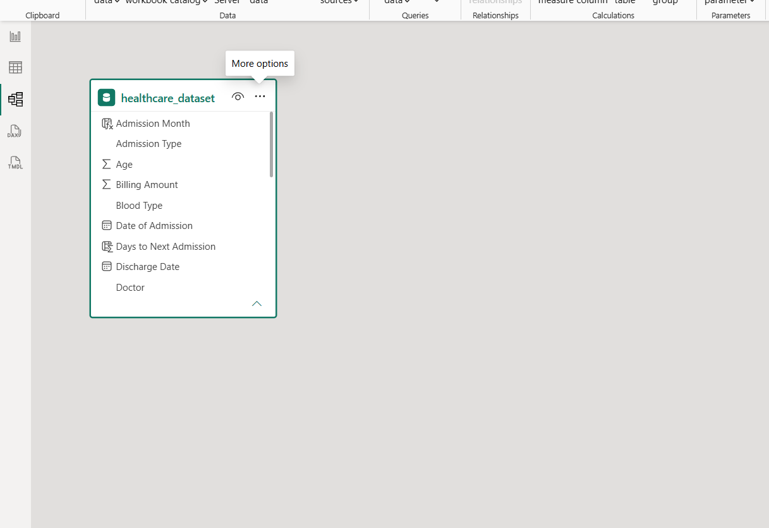

6. Dashboard & Visuals

Describe each page / view in your Power BI report. Include a screenshot of each page.

6.1 Page 1 — Summary / Overview
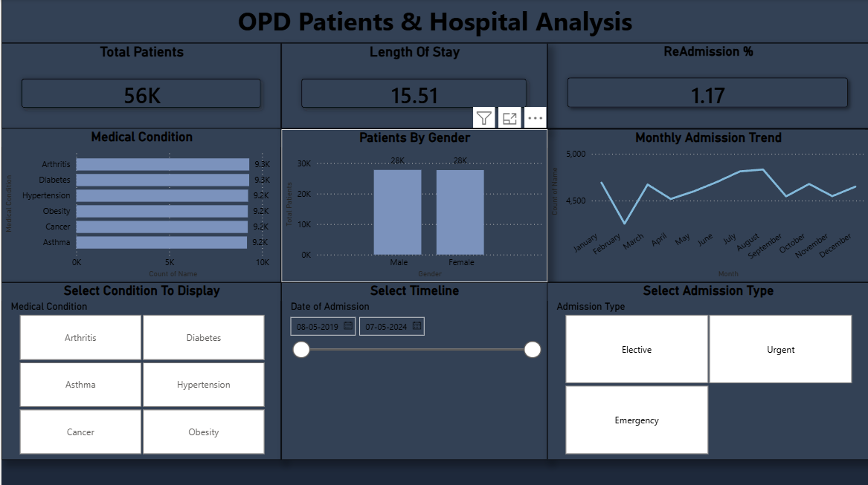
Visuals used on this page:
- KPI Cards — Total Patients, Length of Stay, ReAdmission %
- Bar Chart — Patients by Medical Condition
- Line Chart — Monthly Admission Trend
- Column Chart — Patients by Gender
- Slicers — Medical Condition / Timeline / Admission Type
Key insight from this page: At a glance, 56K patients were admitted with an average stay of 15.51 days and a low 1.17% readmission rate, with admission volume spread evenly across all six tracked medical conditions and both genders — signalling stable OPD load and strong discharge quality.

6.2 Page 2 — Patient Details
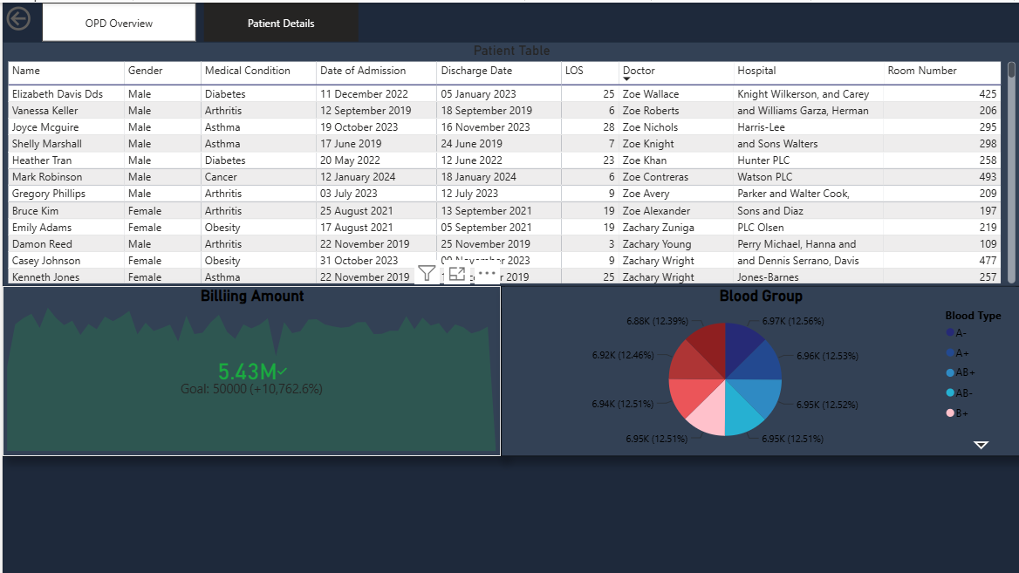
Visuals used: Patient Table (Name, Gender, Medical Condition, Admission/Discharge Date, LOS, Doctor, Hospital, Room Number), Billing Amount KPI vs Goal, Blood Group Pie Chart, and a Page Navigator to switch between the Overview and Patient Details pages.
Key insight: Total billing reached Rs. 5.43M against a Rs. 50,000 goal (+10,762.6%), while all eight blood groups stay tightly clustered between 12.39% and 12.56%, showing a well-balanced and representative patient base.

6.3 Navigation & Cross-Filtering
Navigation used: a page-navigator tab bar (OPD Overview / Patient Details) lets users switch between the summary and record-level pages.
What this enables: clicking or hovering a bar, line, or column visual on the Overview page cross-filters the related visuals on the same page, letting a viewer isolate a single condition, month, or gender without leaving the page. A dedicated drill-through page was not built in this version and is listed under Future Scope.

7. Key Findings & Insights

Summarise the top insights your dashboard revealed. Write each insight as a clear, factual statement supported by data. Aim for at least 5 insights.

- Finding 1: Patient load is spread almost evenly across all six tracked medical conditions (9.2K-9.3K admissions each), so no single diagnosis dominates OPD capacity planning.
- Finding 2: Monthly admissions hold a steady 4,500-5,000 patient band, with a visible peak in August — useful for staffing and bed-allocation forecasts.
- Finding 3: Gender split is nearly identical (28K male vs 28K female), confirming the patient base is balanced across demographics.
- Finding 4: Average length of stay is 15.51 days against a low 1.17% readmission rate, indicating strong discharge planning and follow-up care rather than a cause for concern.
- Finding 5: Total billing of Rs. 5.43M far exceeds the Rs. 50,000 goal, and all eight blood groups stay within a tight 12.4%-12.6% band, showing balanced billing performance and a representative patient mix.

8. Learnings & Challenges

8.1 Skills Learned
- Connecting to and transforming raw CSV data using Power Query.
- Evaluating when a single flat table model is more appropriate than a star schema, based on the structure of the source data.
- Writing DAX measures and calculated columns using DATEDIFF, DIVIDE, CALCULATE, FILTER, and ALL.
- Designing user-friendly dashboards with slicers, page navigation, and cross-filtering.
- Understanding DAX row context vs. filter context and context transition — critical for building the readmission proxy measure correctly, and for realising that DAX's default text comparison is case-insensitive.

8.2 Challenges Faced
- Challenge 1: The original 'Readmission %' card used SUM aggregation on a per-row percentage column instead of AVERAGE, producing a meaningless inflated result. Fixed by rebuilding it as a proper measure instead of relying on an implicitly aggregated column.
- Challenge 2: On closer inspection, the underlying calculated column itself was mislabeled — its DAX formula actually measured the percentage of Urgent/Emergency admissions, not real patient readmissions, since the dataset has no repeat-visit logic built in.
- Challenge 3: The dataset has no Patient ID, so a true readmission rate could not be computed directly. Built a Name-based proxy using CALCULATE, FILTER, and ALL() to find each patient’s next admission date and flag a readmission when the gap from discharge was 30 days or less.
- Challenge 4: A manual spot-check of the readmission logic initially gave a much lower count than the DAX measure. The mismatch was traced to DAX's default case-insensitive text comparison versus a case-sensitive manual check — once both were aligned, the 1.17% figure was confirmed correct.

9. Conclusion

Write a 100–150 word conclusion summarising the project. Mention:
- Whether the original problem statement was addressed.
- The value the dashboard adds to the intended user.
- What you would improve or add if given more time.

This project demonstrates a complete Power BI workflow — from a raw 55,500-row Kaggle dataset to a two-page, interactive OPD dashboard — addressing the original problem of fragmented, manually compiled patient and billing reports. The dashboard gives OPD management a live view of patient inflow, length of stay, and billing, along with a validated 1.17% readmission measure that survived a genuine debugging process rather than being taken at face value. Given more time, the readmission logic could be strengthened with a real Patient ID field, and a predictive readmission-risk model and cost-per-condition page could be added using the Billing Amount and Insurance Provider fields already present in the data. This training experience sharpened my Power Query, DAX, and data-modelling skills, and taught me to question a KPI’s calculation logic rather than trust the number a card displays.

10. References

- Microsoft Power BI Documentation — https://docs.microsoft.com/en-us/power-bi/
- Dataset Source — Healthcare Dataset, Kaggle — https://www.kaggle.com/datasets/prasad22/healthcare-dataset
- DAX Reference Guide — https://dax.guide/
- Power Query M Reference — https://docs.microsoft.com/en-us/powerquery-m/
- [Add any YouTube tutorials, courses, or articles you personally referred to — e.g., channel name and video title.]

END OF REPORT

